**Choosing a dataset**

I am doing data visualization on the bank credit scoring. Which is the same as the first assignment. The modification details are in the first assignment report.

**Analysis of the descriptive question**

What kind of people will have better credit score? What is the relationship between number of loans held by people and credit score?

**Analysis of the predictive question**

How many loans are people likely to have given the period people holding the loan.

**NLQ**

Number of delayed payment and outstanding debit by credit score.

Number of credit card by credit score.

Credit score hierarchy colored by monthly balance and sized by num of loan.

Num of loan by credit history age

Average annual income by credit score

**Top 3 drivers for the query**

Num_of_Delayed_Payment

Annual_Income

Monthly_Inhand_Salary

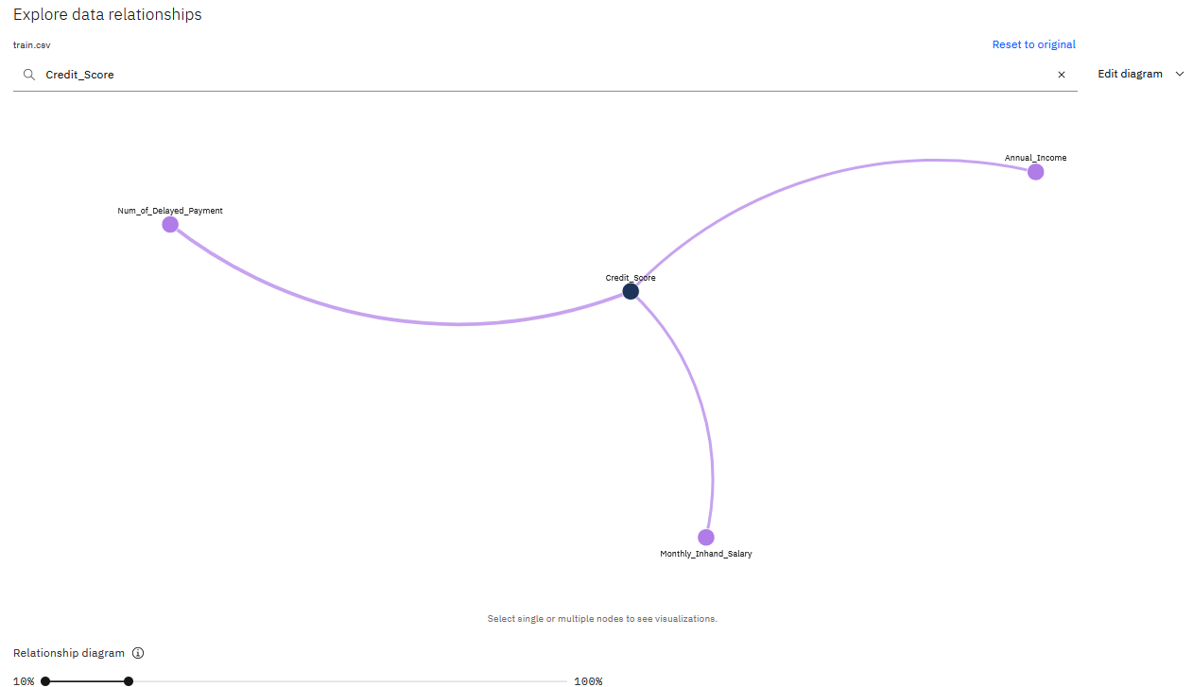

**Decision Tree**

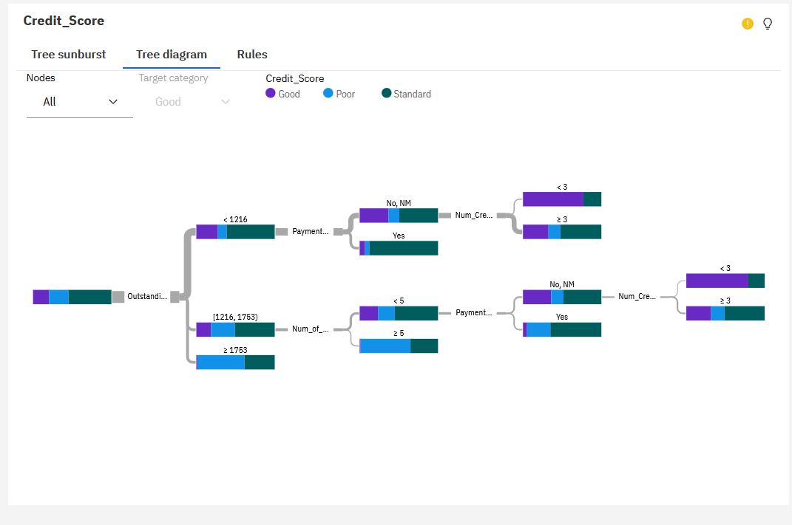

**Rules for predictions**

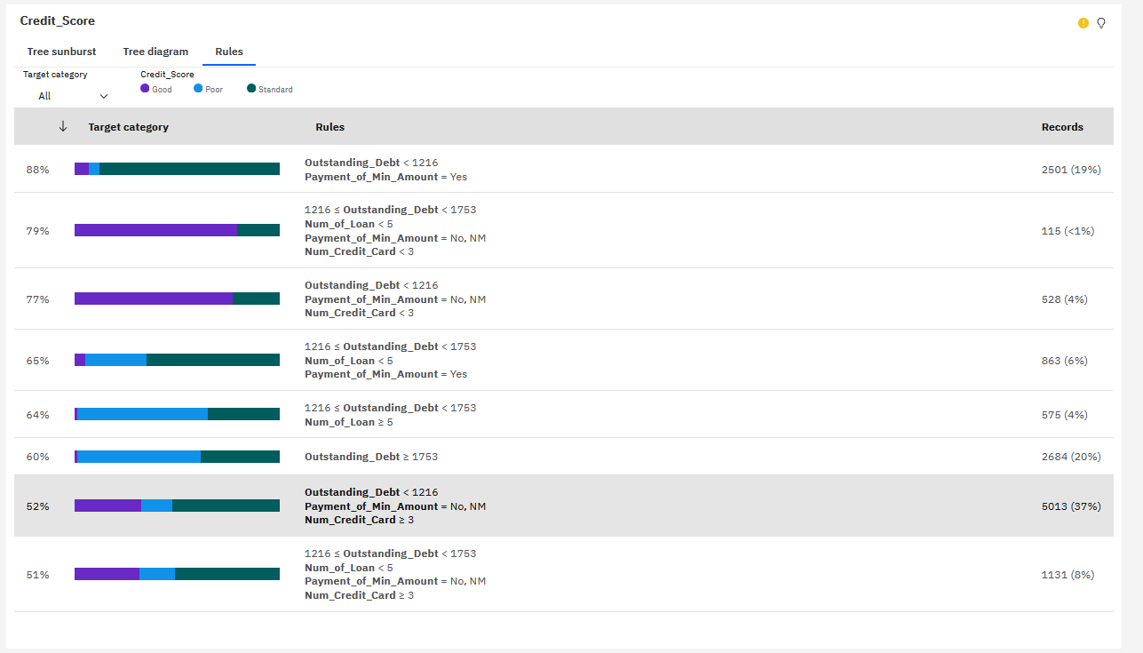

**5 charts and explaining**

**1**

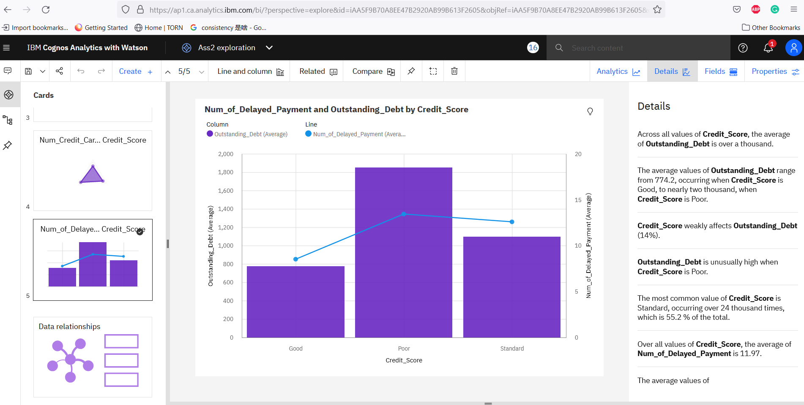

The bar chart shows the outstanding debt, whereas the line chart shows the number of delayed payments. We can see people with Poor credit score tends to have more outstanding debt and also have more delayed payment. Yet people with good credit score have less outstanding debt and delayed payment.

2

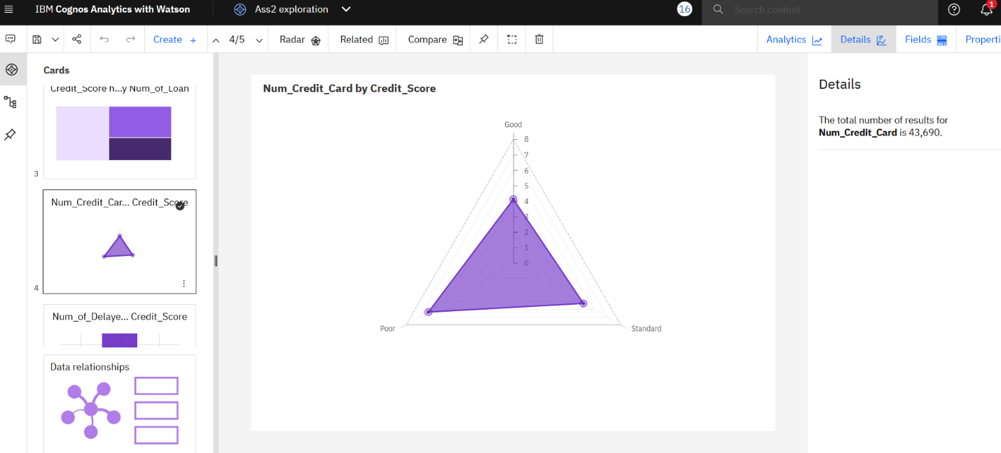

In this chart, we can see people with good credit score has less credit cards on average. And people with poor credit score have more credit cards on average.

3

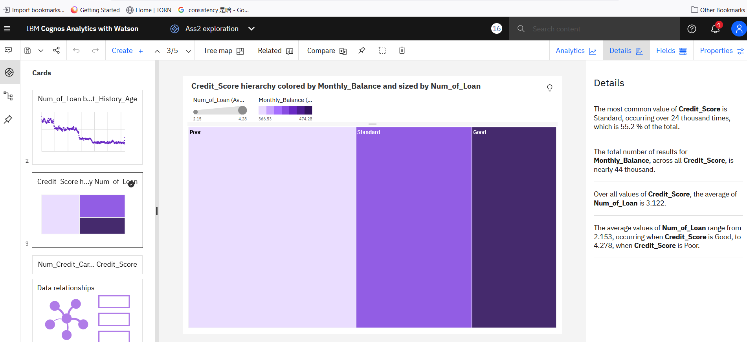

In this chart, size of the bars shows number of loans people have on average.

The average monthly balance was shown with different colors.

We can see people with good credit score have higher monthly balance and less num_of_loan.

4

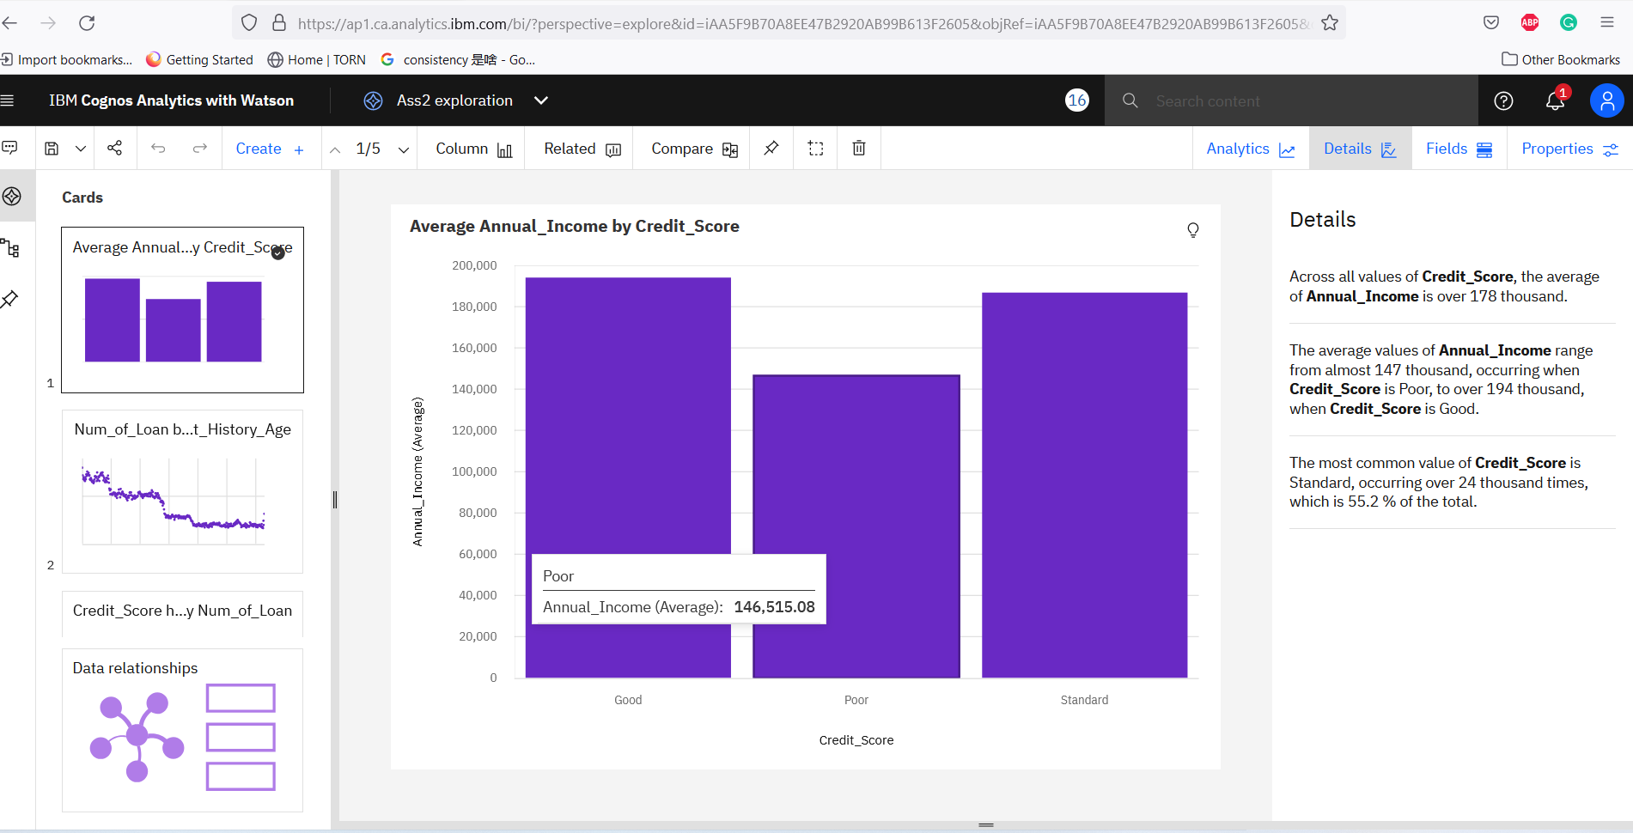

In this chart, x-axis shows credit score and the y-axis shows annual income.

We can see people with good credit scores are with higher average annual income (around 195,000), whereas standard-credit-score people have around 185,000 and poor-credit-score people have around 156,000.

5

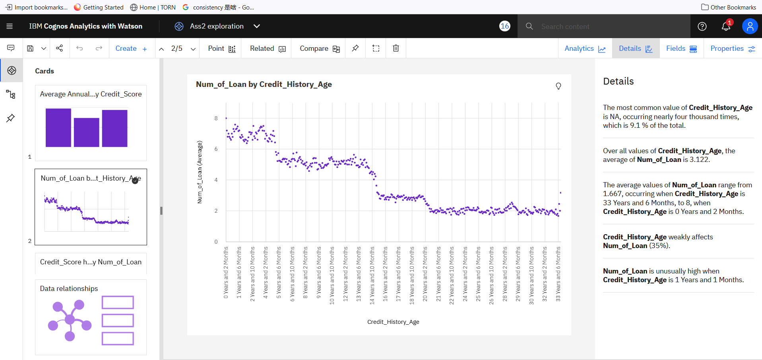

In this chart, we can see the people with longer credit history tends to have less loan on average.

People who have less than 4 years of credit history has largest number of loans (from 6 to 8 loans). Whereas people with more than 20 years credit history have only 2 loans on average.

**Dashboard and metrics**

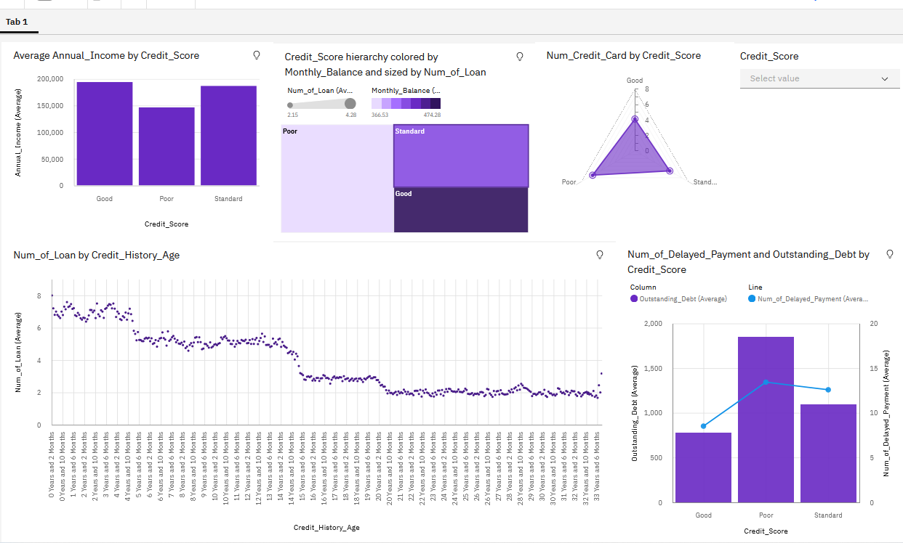

With drilldown(good, poor, standard)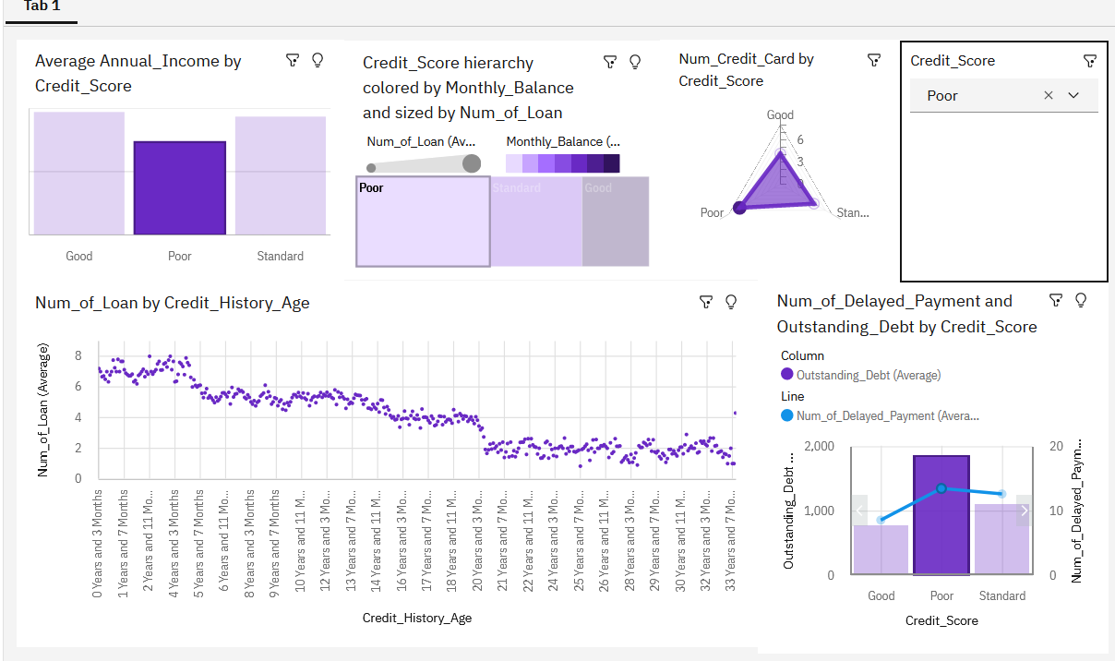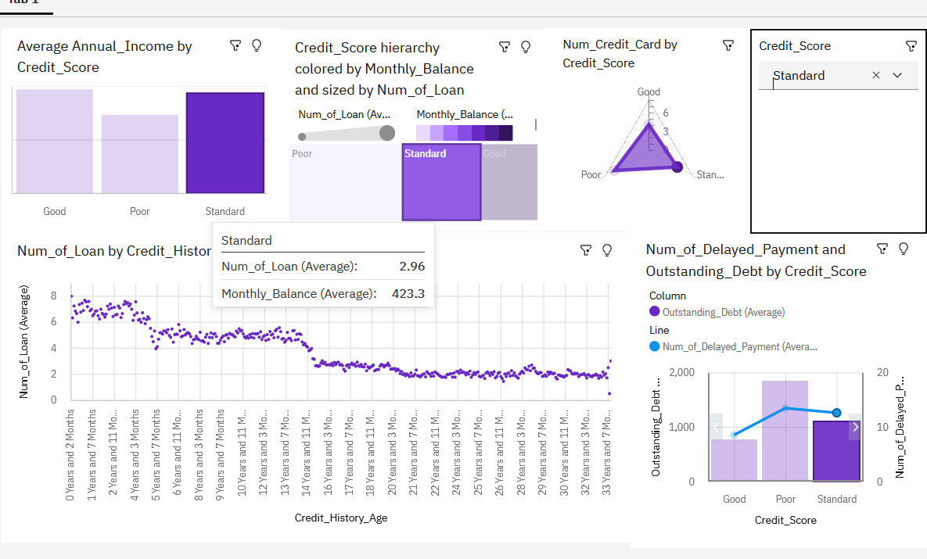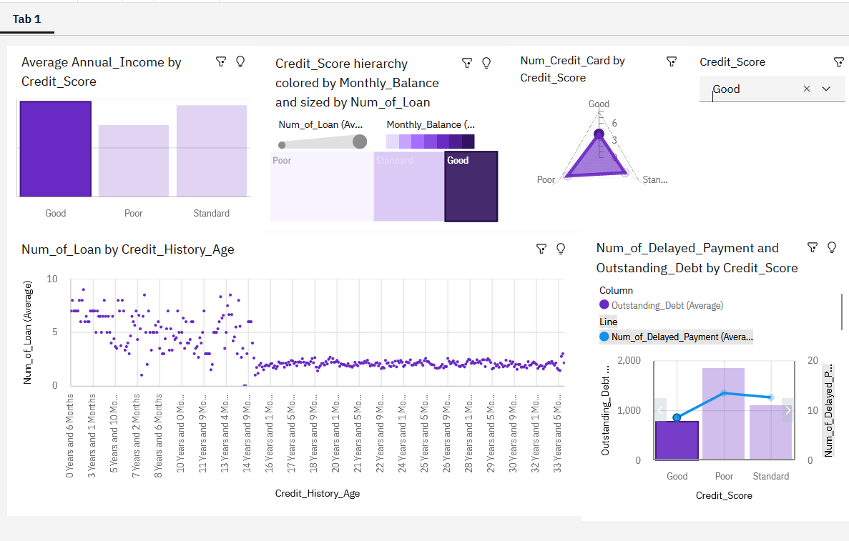

**Conclusion**

With these charts, we can see the relationship between these attributes.

We can indicate what kind of people will have better credit score and what is the relationship between number of loans held by people and credit score.

People with around 19500 Annual income, around 2(2.15) loans, around 4 credit cards(4.13), around 9(8.51) delayed payments and around 774 outstanding debt are more likely to have a good credit score.

According to the chart 5, we can also give out a prediction: The longer people having credit card, the less loans people tends to have.